**Problem:**

Lot of information which is similar in nature has been generated and is stored in form of records or ledgers at different places or databases which actually can be stored at single database that can reduce cost and effort to maintain them. As similar data is stored in different databases that is ineffective, costs more and can be vulnerable and moreover it is not easy to access it. If there is a difference in data records at which are stored at different data bases, then it would be uncertain to know which data accurate and which data is to be considered. There is no way to decide which data stored is genuine and this creates a lot of confusion amount the people accessing them.

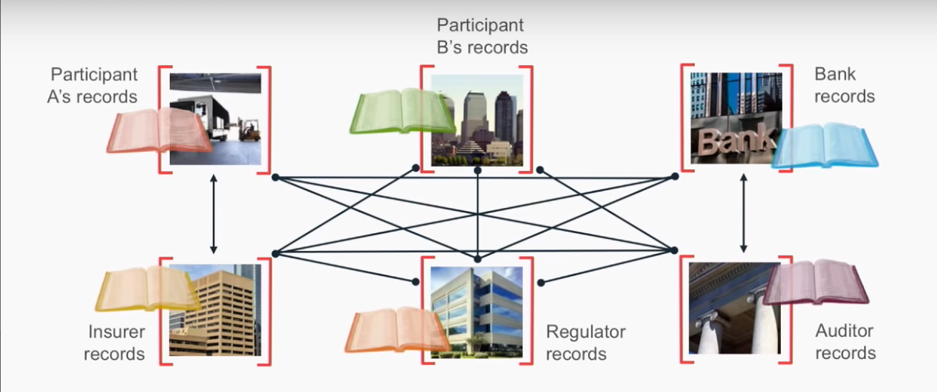

**Technology/ Solution to address the problem:**

A Distributed Ledger Technology (DLT) is Decentralization of networks and making it spread over a chain of systems. There is no central administrator or centralized data storage. It is the first form of ledger that eliminates the need of third-parties and reduces the rate of error that can occur in ledgers. The distributed ledger database is spread across several nodes (devices) on a peer-to-peer network, where each replicate and saves an identical copy of the ledger and updates itself independently. The primary advantage is the lack of central authority. When a ledger update happens, each node constructs the new transaction, and then the nodes vote by consensus algorithm on which copy is correct. Once a consensus has been determined, all the other nodes update themselves with the new, correct copy of the ledger. Security is accomplished through cryptographic keys and signatures. One form of Distributed Ledger Technology (DLT) is Blockchain.

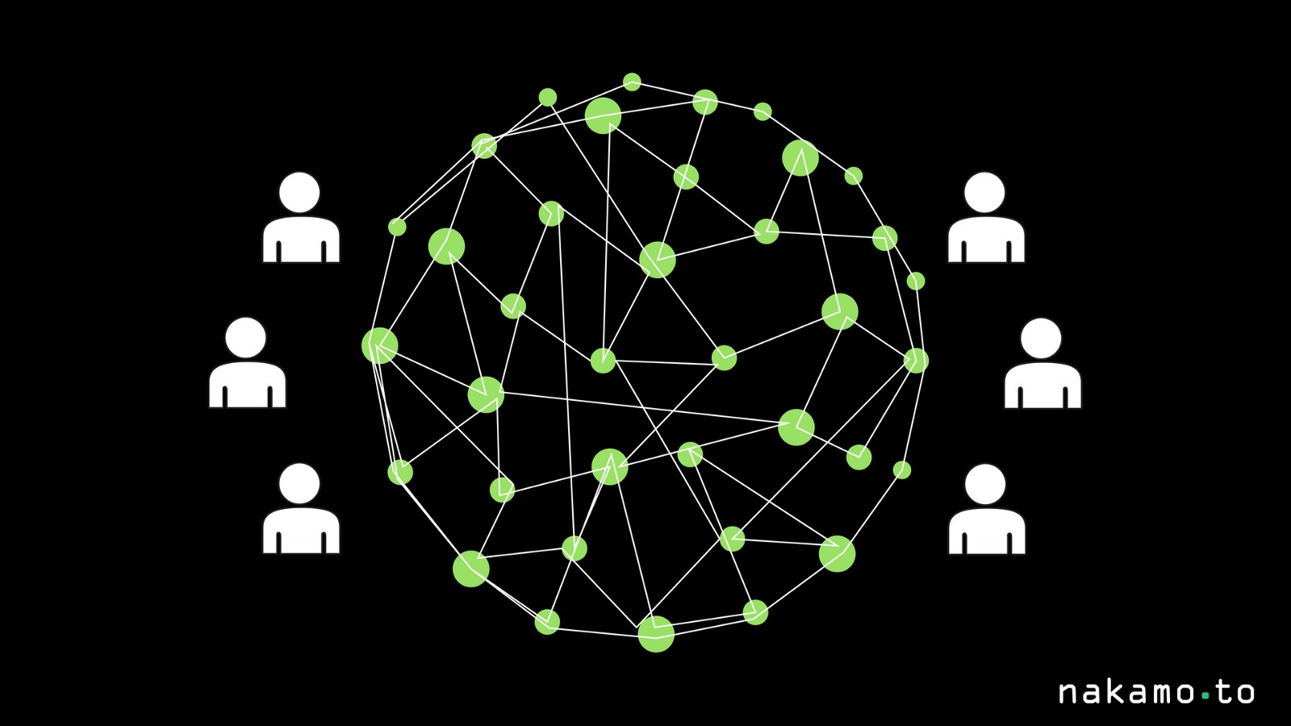

**Fig:** A Distributed Ledger Technology (DLT)

A Blockchain is a Distributed Ledger Technology, a record of transactions that occur in a network and in the case of above problem Blockchain solves the problem by providing a shared replicated Ledger where there is one ledger and we all have a copy of it and can update it. Blockchain is first introduced and applied for Bitcoin but it is applicable for all digital asset transactions carried online. In this case it is permissioned as well i.e. I am permissioned to see what I am supposed to see and nothing more than that. For example, in the case of MYCONTEXT Cancer Patient records of you are a client you can only see the information of the data stored but not the entire data and if you are the patient then you can view your entire record of data that6 is stored in the ledger but can not make any changes like create, update and deletion of records. Moreover, Blockchain provide four major characteristics like consensus, provenance, immutability, finality. In Blockchain every change that is made in Ledger is verified, should be agreed by all using the Blockchain and if any changes are made, we can track the person who made those changes and what changes he made. We can use the Blockchain Ledger to track the history of the asset, track back to its origin and see where it came from. Once something gets recorded in the Blockchain Ledger it is there forever and cannot be deleted. Blockchain Ledger is the final source of truth and provides all the authenticity required for the data stored in the Ledger.

For example, A wants to make a money transaction to B. The entire transaction is represented online through a block. Then the block is broadcasted to every party in network. The transaction gets approved by those who are present in the network in our case it may be a bank or a financial institution. The validation of transaction is carried on two bases i.e., the sender A has to be the part of the network and have to possess sufficient money to make the transaction. After these two cases the transaction is approved and recorded into a block providing an indelible and transparent record. Now, the money moves from A to B.

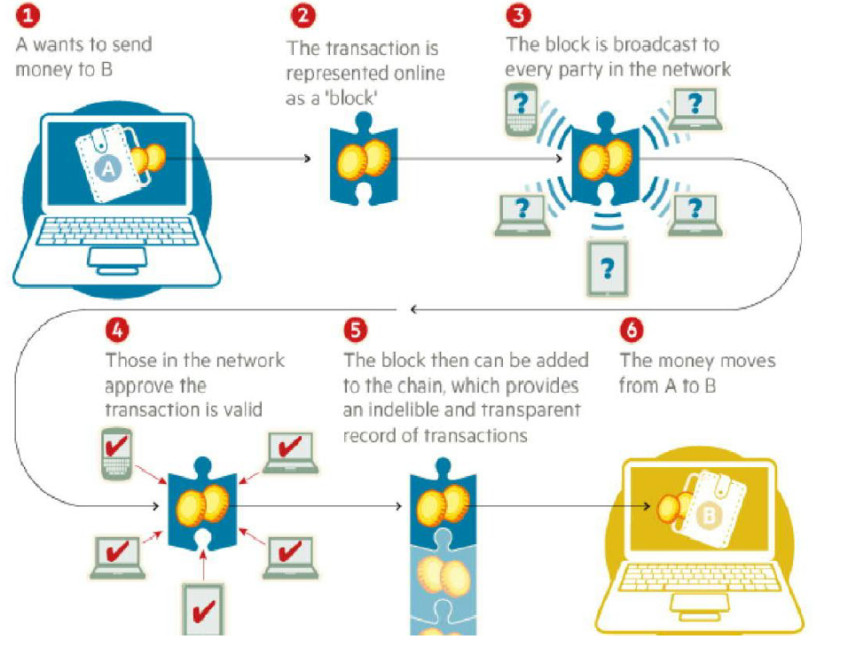

**Fig:** Blockchain

**Hyperledger:**

Hyperledger composer is a relative framework to accelerate the development of solutions build on Blockchain platforms such as Hyperledger Fabric. The need of Hyperledger came into line light because in the past is if very difficult to build Blockchain technologies on the top of existing technologies. It is very technical and is very new. For business, though they have working use cases thought there are use cases it is very difficult to turn them into working production deployment. All these problems can be addressed with Hyperledger composer which emphasis on delivering solutions quickly by using business centric vocabulary.

Before all the Blockchain technologies are technical and focuses on key values but in the composer, we concentrate more on business use cases like assets, participants and transactions that occur within their business put into the Blockchain. To build an application around the Blockchain a business centric API is given, where it can be used to submit transactions, create assts, update assets, remove assets and can work with participants and permissions as well. All that data gets stored on the Blockchain both in the ledger and the database. Blockchain can be easy integrated with existing business process and systems of records.

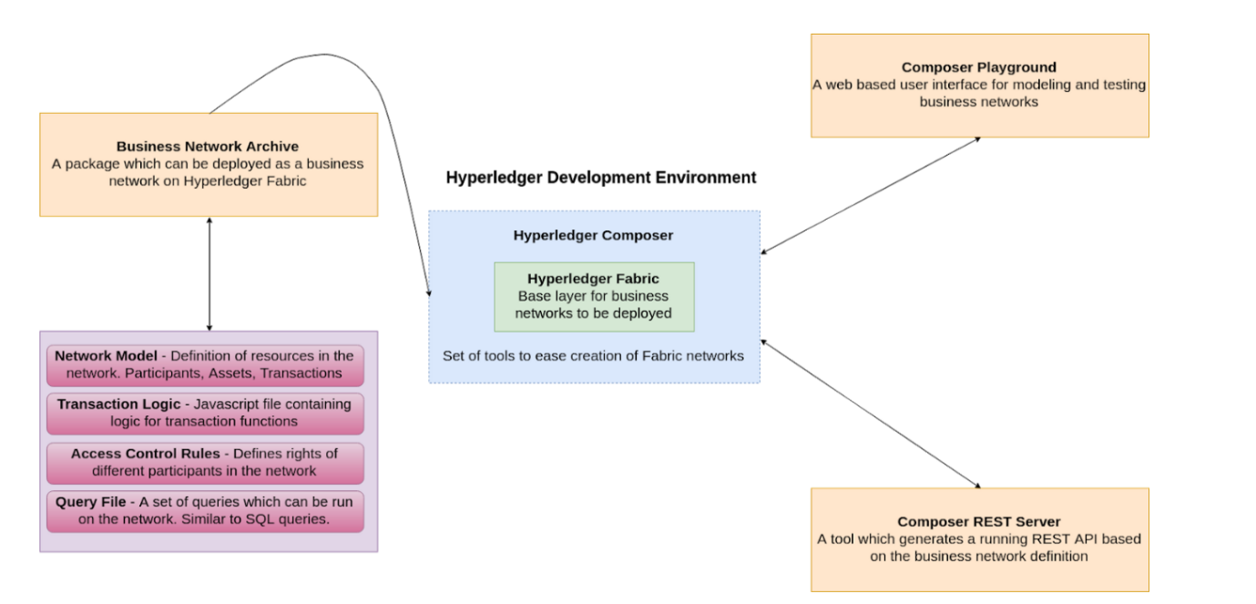

**Fig:** Development environment overview for Hyperledger

**Hyperledger Composer** is a set of JavaScript based tools and scripts which simplify the creation of Hyperledger Fabric networks. Using these tools, we can generate a **business network archive (BNA)** for our network. Composer broadly covers these components:

* Business Network Archive (BNA)
* Composer Playground
* Composer REST Server

Hyperledger Fabric is an open source framework for making private (permissioned) blockchain business networks, where identities and roles of members are known to other members. The network built on fabric serves as the backend, with a client-side application front-end. SDK’s are available for Nodejs and Java to build client applications, with Python and Golang support coming soon.

A Business Network Architecture (BNA) is a package that are different files and generate an archive which can be deployed as a business network on Hyperledger Fabric. To generate the fabric, we need:

* Network Model: A definition of the resources present in the network. These resources include Assets, Participants, and Transactions.
* **Business Logic :** Logic for the transaction functions
* **Access Control Limitations:**Contains various rules which define the rights of different participants in the network. This includes, but is not limited to, defining what Assets the Participants can control.
* **Query File (optional):**A set of queries which can be run on the network. These can be thought of as similar to SQL queries.

Composer Playground is a web-based user interface that we can use to model and test our business network. Playground is good for modelling simple Proofs of Concept, as it uses the browser’s local storage to simulate the blockchain network. However, if we are running a local Fabric runtime and have deployed a network to it, we can also access that using Playground. In this case, Playground isn’t simulating the network, it’s communicating with the local Fabric runtime directly.

Composer REST Server is a tool which allows us to generate a REST API server based on our business network definition. This API can be used by client applications and allows us to integrate non-blockchain applications in the network.

Pre-requisites are something that are required prior to an operation or something else to happen next. We do all the work related to Hyperledger composer and Blockchain technology in our Virtual Machine that contains all the properties and software that get our program running.

The following are the pre-requisites for installing and working of required development tools:

* Machine
* Docker Engine: Version 17.3 or higher
* Docker-Compose: Version 1,8 or higher
* Node: 8.9 or higher (note version 9 and higher is not supported)
* Nodejs and NPM: v5.x
* Git: 2.9.x or higher
* Python: 2.7.x
* A code editor of choice, preferably VSCode

To create a Blockchain we need a Hyperledger Composer that can be created by following the steps available in IDM documentation[1]. To setup Hyperledger Composer we need install the required software which are pre-requisites, installing the development environment, updating the development environment. In this project we have used Virtual Machine (VM) in which Ubuntu is loaded in it.

For systems running on Ubuntu we can install pre-requisites by using the command

curl -O https://hyperledger.github.io/composer/latest/prereqs-ubuntu.sh

chmod u+x prereqs-ubuntu.sh

Next run the script - as this briefly uses sudo during its execution, you will be prompted for your password.

./prereqs-ubuntu.sh

**Installing the development environment**

Follow these instructions to obtain the Hyperledger Composer development tools (primarily used to create Business Networks) and stand up a Hyperledger Fabric (primarily used to run/deploy your Business Networks locally). Note that the Business Networks you create can also be deployed to Hyperledger Fabric runtimes in other environments. Before you begin make sure you have installed the pre-requisites.

**Installing components**

**Step 1: Install the CLI tools**

There are few useful CLI tools for Composer developers. The most important one is composer-cli, which contains all the essential operations, so we'll install that first. Next, we'll also pick up generator-hyperledger-composer, composer-rest-server and Yeoman. Those last 3 are not core parts of the development environment, but they'll be useful.

1. Essential CLI tools:

npm install -g composer-cli@0.20

1. Utility for running a REST server on your machine:

npm install -g composer-rest-server@0.20

1. Useful utility for generation of application assets:

npm install -g generator-hyperledger-composer@0.20

1. Yeoman is a tool for generating applications, which utilises generator-hyperledger-composer:

npm install -g yo

**Step 2: Installing Playground**

You can run this locally on your development machine too, given you a UI for viewing and demonstrating your business network.

1. Brower app for simple editing and testing Business Network:

npm install -g composer-playground@0.20

**Step 3: Setup your IDE**

Whilst the browser app can be used to work on your Business Network code, most users will prefer to work with IDE.

1. Install VSCode from this UR: <https://code.visualstudio.com/download>
2. Open VSCode, go to extensions, then search for and install the Hyperledger Composer extension.

**Step 4: Install Hyperledger Fabric**

This step gives a local Hyperledger Fabric runtime to deploy your Business Networks to.

1. In a directory of your choice get the .tar.gz file that contains the tools to install Hyperledger Fabric.

mkdir ~/fabric-dev-servers && cd ~/fabric-dev-servers

curl -O https://raw.githubusercontent.com/hyperledger/composer-tools/master/packages/fabric-dev-servers/fabric-dev-servers.tar.gz

tar -xvf fabric-dev-servers.tar.gz

A zip is also available if you prefer . Just replace the .tar.gz file with fabric-dev-servers.zip and the tra -xvf command with an unzip command in the preceding snippet.

1. Use the scripts you just downloaded and extracted to download a local Hyperledger Fabric v1.2 runtime

cd ~/fabric-dev-servers

export FABRIC_VERSION=hlfv12

./downloadFabric.sh

Now we got everything required for the typical Development Environment.

**Updating the Development Environment**

Follow these instructions if you have already installed the Hyperledger Composer development tools and wish to update your installation to latest version.

**Updating Components**

**Step 1: Update the CLI tools**

Any running instances of CLI tools should be stopped before continuing. If you have any running instances of the Composer REST server, ensure that those instances are stopped before continuing. You can look for the process composer-rest-server if you are not sure if there are any running instances.

1. Uninstall the currently installed version of all the CLI tools

npm uninstall -g composer-cli composer-rest-server generator-hyperledger-composer

1. Install the latest version of all CLI tools

npm install -g composer-cli@0.20 composer-rest-server@0.20 generator-hyperledger-composer@0.20

**Step 2: Update Playground**

If you have installed the browser app “Playground” on your development machine, you will need to update it as well. If you have any running instances of the browser app, ensure that those instances are stopped before continuing. You can look for the process composer-playground if you are not sure.

1. Uninstall the currently installed version of browser app

npm uninstall -g composer-playground

1. Install the latest version of the browser app

npm install -g composer-playground@0.20

Now, we have updated your browser app with the latest version

**Uninstalling the Development Environment**

Follow these instructions if you have already installed the Hyperledger Composer environment and would like to uninstall it to update to the latest version or you no longer require the development environment.

**Uninstalling Components**

**Step 1: uninstall the CLI tools**

Any running instances of CLI tools should be stopped before continuing. If you have any running instances of the Composer REST server, ensure that those instances are stopped before continuing. You can look the process composer-rest-server if you are not sure if they are any running instances.

1. Uninstall the currently installed version of CLI tools

npm uninstall -g composer-cli composer-rest-server generator-hyperledger-composer

**Step 2:Uninstall Playground**

If you have installed the browser app “Playground” on your development machine, you will need to uninstall this as well. If you have any running instances of the browser app, ensure that those instances are stopped before continuing. You can look for the process composer-playground if you are no sure if there are any running instances.

1. Uninstall the currently installed version of the browser app

npm uninstall -g composer-playground

**Step 3: Remove the business network card store**

Business network cards are stored in a business network card store, which by default is a directory in the current user home directory. Delete this directory to remove all business network cards. Be warned that this will also delete all identities that are stored in the business network card store, so you may wish to back them up before continuing.

1. Remove the business network card store

rm -rf ~/.composer

**Step 4: Uninstall Hyperledger Fabric**

You can control your local Hyperledger Fabric runtime using a set of scripts which you will find in ~/fabric-dev-servers if you followed the suggested defaults

1. Stop the local Hyperledger Fabric runtime and remove any runtime Docker containers or images

export FABRIC_VERSION=hlfv12

~/fabric-dev-servers/stopFabric.sh

~/fabric-dev-servers/teardownFabric.sh

1. Uninstall the local Hyperledger Fabric runtime

rm -rf ~/fabric-dev-servers

After completing this you have uninstalled your development environment.

After getting the necessary pre-requisites create an asset file, declare the participants that who are going to be in the Blockchain technology, transactions like which type of transactions are going to take place in Blockchain. Asset file is basically the data regarding the digital assets which can be cryptocurrency, patient digital records, details related to any property etc. Asset file is inclusion of all the details of property or records that one would like to sell but they have to be in digital form. MYCONTEXT cancer patient records contains the asset file that contains all the information regarding a patient like name, age, sex, address, hospital the patient has been admitted into, disease he has been diagnosed with, medicine or drug he has been prescribed.

Participants are decided based upon the type of transaction that is going to take place in Blockchain. For a transaction is related to cryptocurrency participants would generally be the person who is going sell his cryptocurrency, the person who is buying the cryptocurrency and the bank which verifies the conditions required for a successful transaction. For MYCONTEXT cancer patient records participants are the patients, the hospital or doctor who creates the records and the client who could be research organisation or a paramedical company that buys the patient medical records.

**Using Playground**

A user interface of Business Network configuration, deployment and testing is provided by the Hyperledger Composer Playground. With the advanced features present in the Playground a user can manage the security, invite participants to network and can make multiple connection to Blockchain Business Network. When multiple users are accessing Hyperledger Playground to link at same occasion of Hyperledger Fabric, then each user has to refresh the browser after the business network definition is updated by another user. Refreshing the browser accepts the changes to business network made by the other users.

**Navigating Playground**

**The Business Network Page**

It is the default landing page where you can all the Business Network Card, we have available to use. This Business Network Cards provide information that is all needed to make connection to a blockchain business network by valid Business Network Card. Once the connection is made to the deployed Business Network Cards, you will be directed to the Define page.

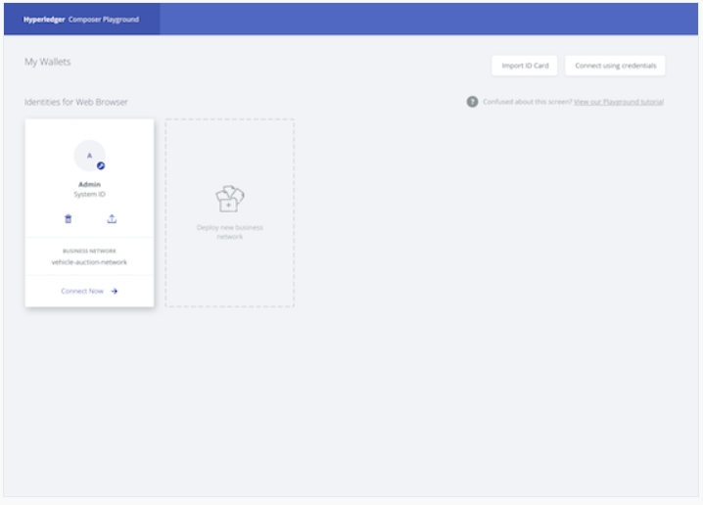

From this page you can:

* Make a connection to Business Network. To the business network you can make a connection between the Business Network Card and deployed business network if it is already created by clicking Connect now.
* Deploy a new business network. Deploying your own new network is a great place to start if you are wished to start a new project or if it is your first time using the Playground. One can create his own network for scratch or choose to use a sample network to base the business network definitions.
* Make Interaction with Business Network Cards. We can connect to the already existing business networks by using Business Network Cards and are a combination of connection profile and identity. We can do the following operation with the help of cards- export the card, delete the card and connection to the corresponding business network.
* Business Network Card importing. The easiest method to add Business Network Card to your Business Network Page is importing the existing .card file from your computer.
* Using user secret and user ID to make connection. We can generate Business Network Card and can connect by clicking on connect using credentials if you are provided with user secret and user ID by your network administrator.

**Business Network Options**

There are number options available once you are connected to a business network using a Business Network Card, there are number of options available whether you are looking at the Define tab or Test tab.



* You can view the connection profile you are using and business network you are connected to at the upper left. In the example above, the connection profile is called Web and the business network is called basic sample network.
* Links to the Define and Test labs. In the Define tab, you can add, modify and delete the content of your business network, and in the Test lab you can create assets and participants that were defined in the Define tab, and test the functionality of your business network.
* The identity which is being used to connect the business network is on upper right as a drop menu. The dropdown contains a link to the Identity Registry, and the ability to log out of the business network, returning to the Business Network page.

**The Define Tab**

you can create, edit and upgrade your business network in Define tab

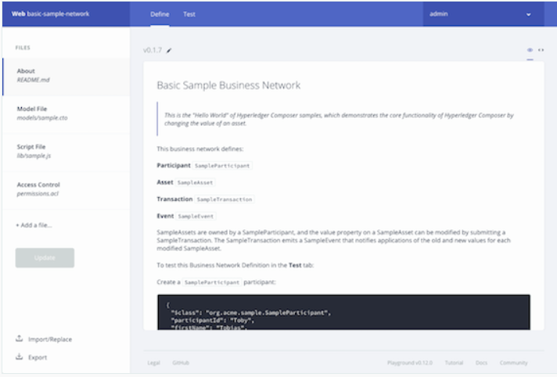

On the left of the Define tab, you can see a list of all the files in your current business network definition. To examine the contents of a file, click on it, and it will appear in the editor view. New files can be added to your business network with the Add a file button. Model files, script files, access control files, and query files can be added to your business network. Once you've added and modified the files for your business network definition, you can deploy the changes to your network with the Deploy changes button. After clicking Deploy changes you can experiment with your changes in the Test tab. The Export button allows you to download your current business network as a .bna file.

**The Test Tab**

The deployed business network is tested in Test tab by using the asset type, participant types and transactions which you define in the Define tab.

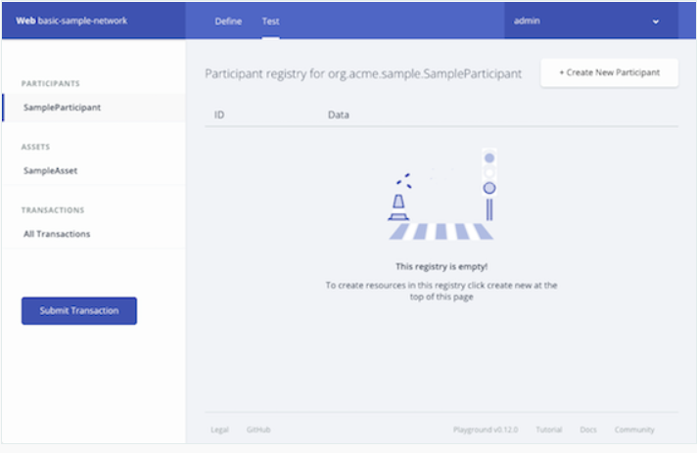

Each participant type and asset type are listed on the test tab. Clicking on a participant type, asset type or all transactions will display a registry, showing all active instances of that type. For example, by clicking SampleParticipant, you can see a registry showing all sampleparticipants that have been created. the registry will be empty if you are looking the Test tab for the first time. You can see a record of each transaction that has taken place in your business network in All transaction registry, including some transactions which are caused by system events. We can submit the transactions and check that their effects gave occurred by checking any changes has occurred in resources or not by transaction registry.

**Business Network Cards**

All the information needed to connect to a blockchain business network is provided by the Business Network Cards. A valid Business Card Network is used to access a blockchain Business Network. A Business Network Card contains and Identify for a single Participant within a deployed business network. To connect to deployed Business Networks, we use Business Network Cards in Hyperledger Composer Playground. One can have multiple Business Network Cards for a single deployed Business Network, where those Business Network Cards belong to multiple Participants.

Business Network Cards are grouped under a Connection Profile, and each card shows the business network that may be accessed using the displayed Identity via the Connect now option. A Business Network Card may be deleted or exported using the icons present in the card.

Here is a Business Network Card that may be used to connect to the business network named my-business-network using the Identity New User.

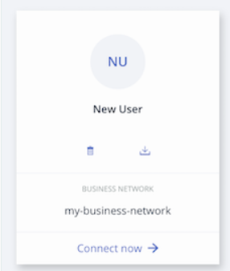

A Business Network Card can be created when an Identity is issued within the Playground. You can export and share this Business Network Card with others, allowing them to connect to the business network using the issued identity. If a user is provided with the Enrolled ID and Secret by an administrator, which corresponding to a valid Identity within a business network, then a Business Network Card may be directly created in Playground.

**Creating a peer admin card using Playground**

For the first time if you are deploying a business network to a Hyperledger Fabric instance requires a Hyperledger Composer chaincode be installed on relevant Hyperledger Fabric peers, and the channel has the relevant business network. A special Hyperledger Fabric privileges are required by a peer or channel administrator.

To create a peer admin business network card

1. From My Business Network screen, click on Create Business Network Card.
2. Select Hyperledger Fabric v1.2 and click Next.
3. Enter the details of your connection profile and click next.
4. Select Certificated and for the peer admin identity upload the certificate and private key information.
5. Give a name for Business Network Card.
6. Select Admin Card, then Peer Admin and Channel Admin.
7. Click Next.

In your My Business Network screen you will find the peer admin card. By using Playground, you can now deploy a business network to Hyperledger Fabric.

**Providing Access to Your Business Network with a Business Network Card**

Through Business Network Card access for Business Network is provided to other users. The Business Network Card can be created and exported to the people for whom it is created. To create a Business Network Card there must be participant present in the Business Network. There is an option to use the saved identity issued within the Playground in Business Network page. By selecting this option, a Business Network card is created for the issued identity that is valid for the current Business Network. The Business Network Card will appear on your Business Networks page once you log out of the current Business Network, and it is from this location where it may be exported to share with another user.

**Creating a Business Network Card**

1. From the Business Network page, select an identity to use to connect to your business network. Click Connect Now. You must use an identity that has permission to create new identities.

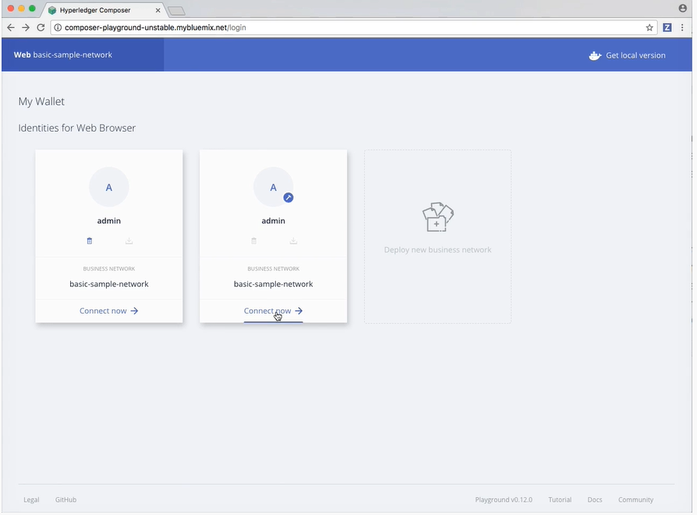

1. If needed, create the participant to which you intend to assign the identity

* To create new participants, click on Test tab and click Create New Participants.

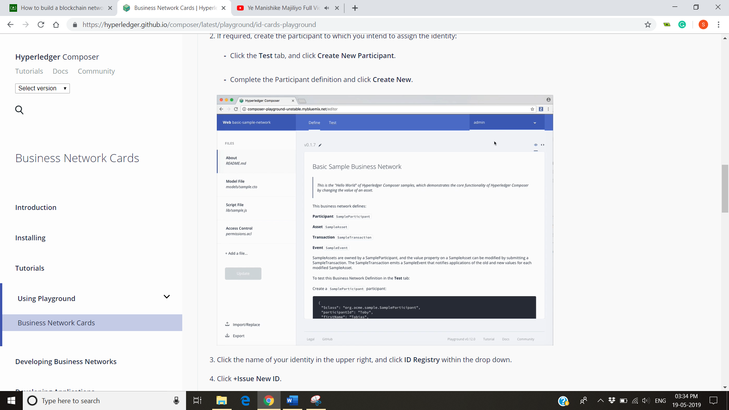

* Complete the Participant definition and click Create New.

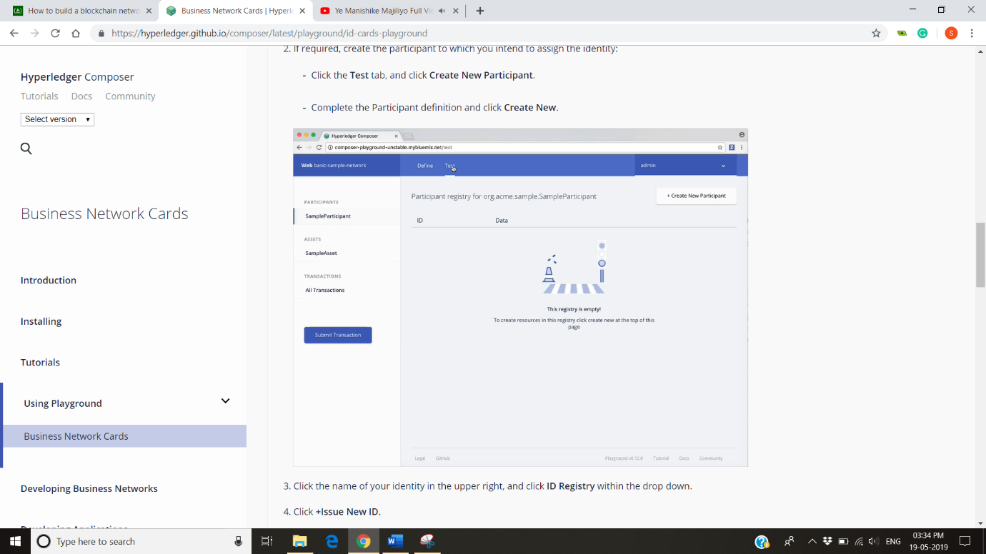

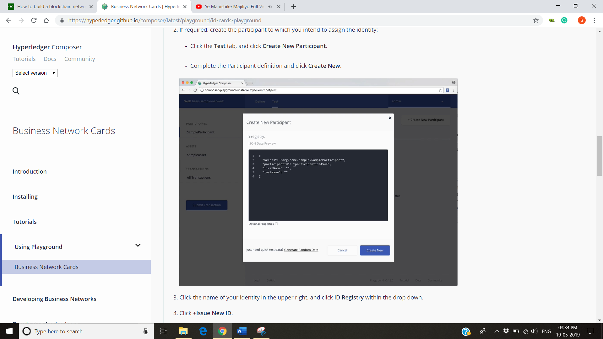

* Create the new participant ID and data.

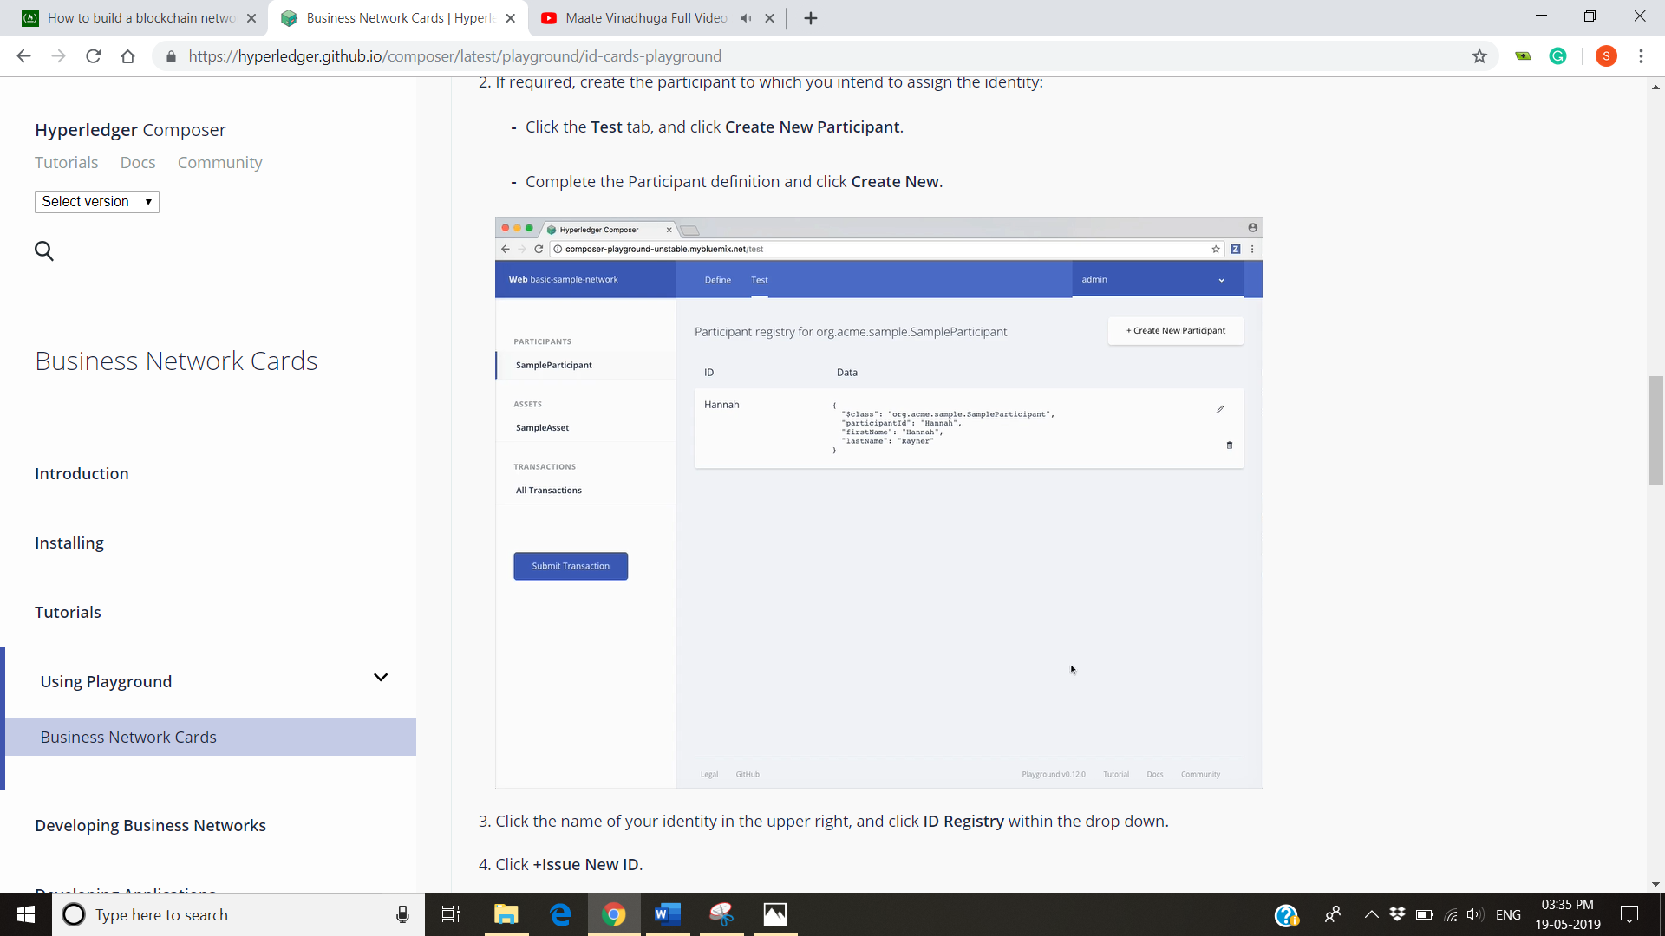

1. Click the name of your identity in the upper right and click ID Register within the drop down.

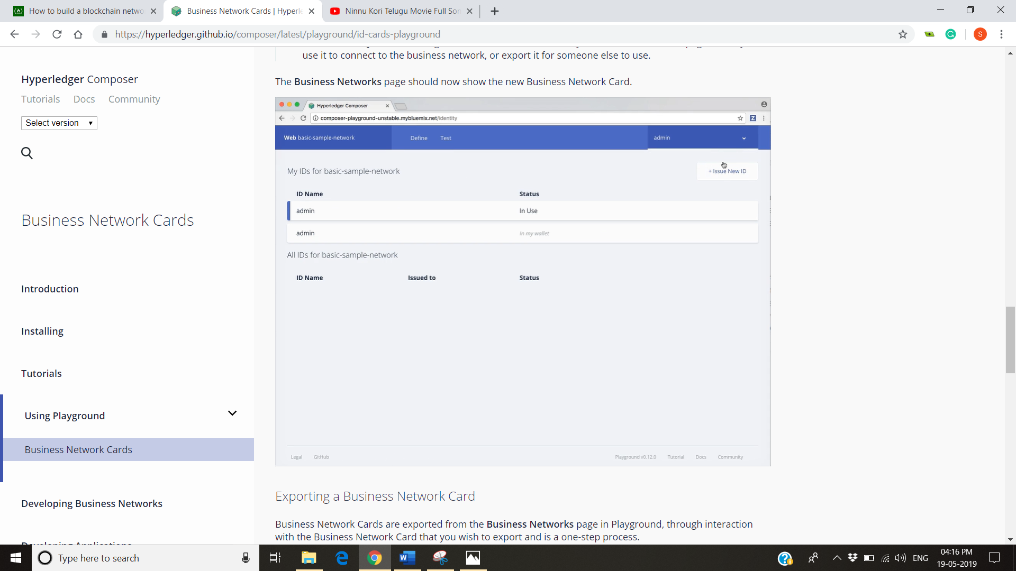

1. Click +Issue New ID.

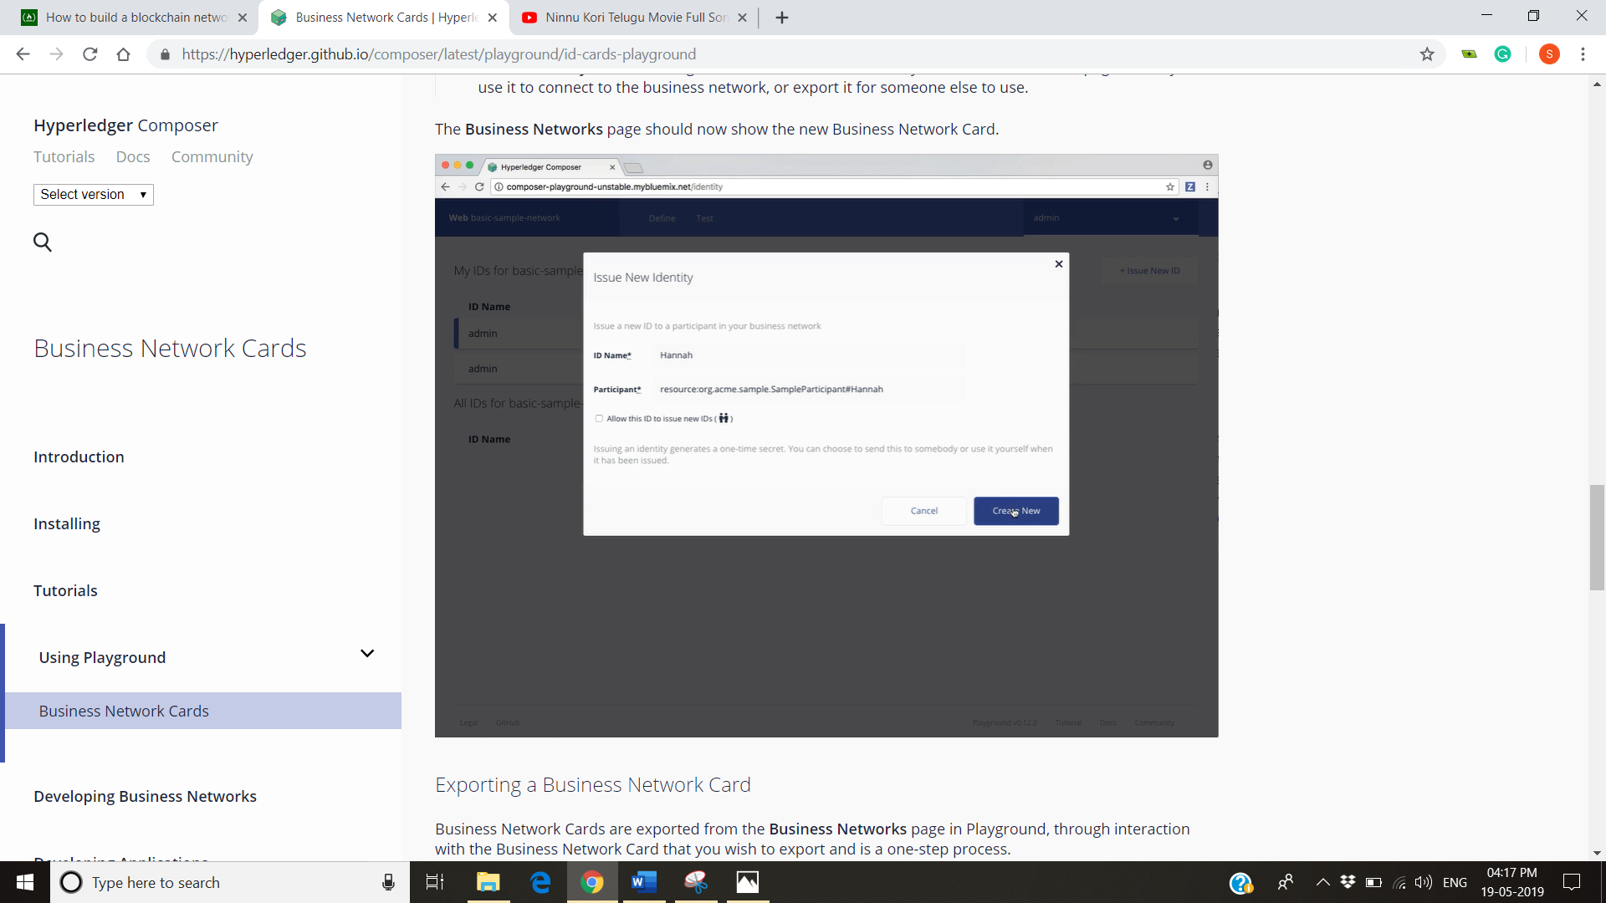

1. Choose an ID Name and input an existing Participant to associate the new identity with. Look- ahead service is provided to auto-complete on known Participants.

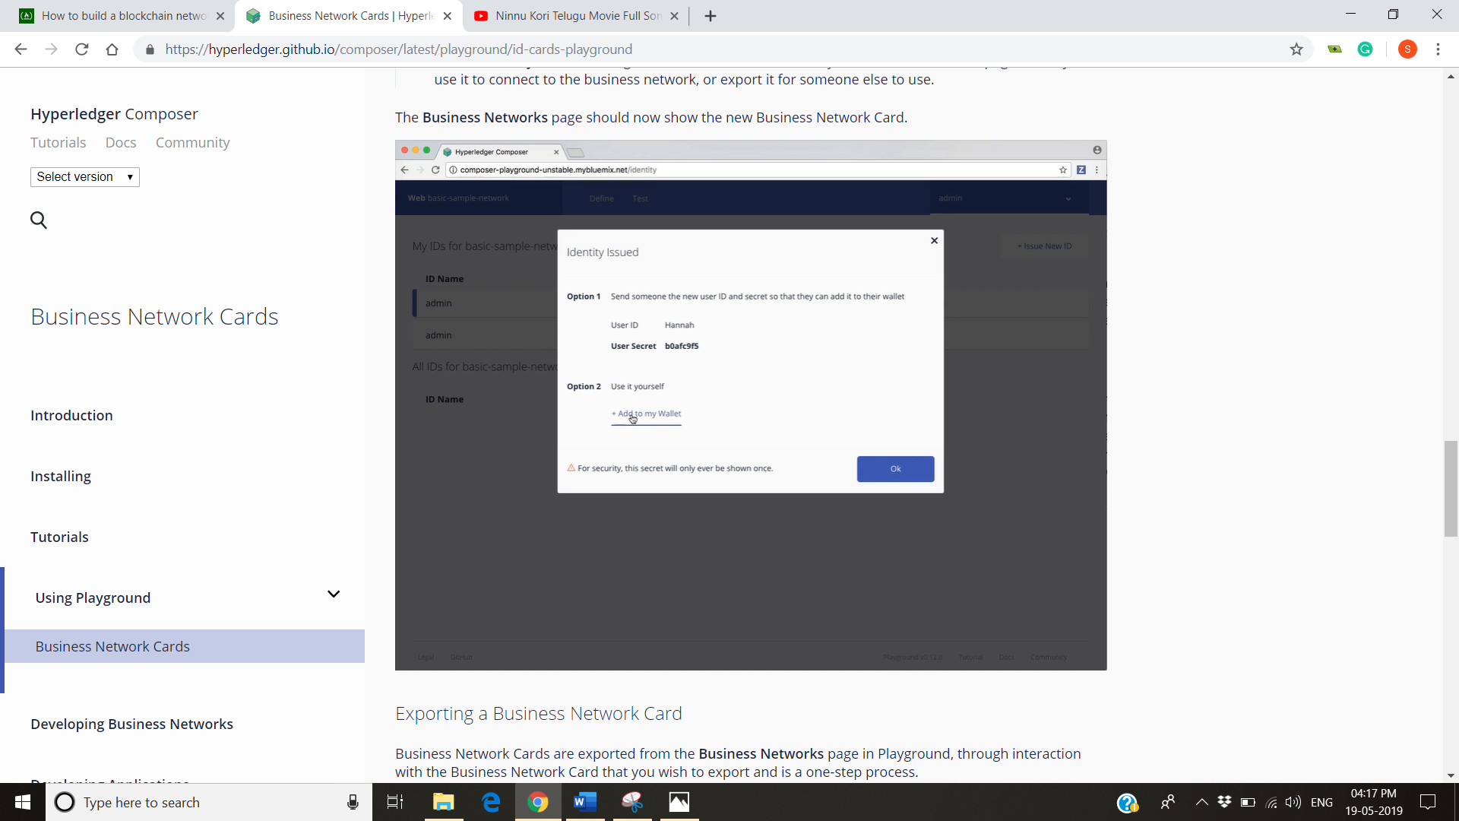

1. Click on Create New.

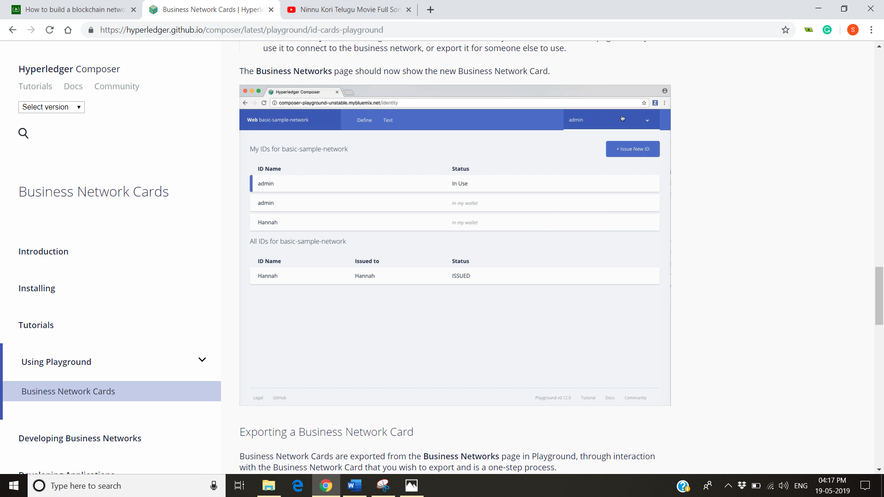

1. Click Add to My Wallet. Adding the Business Network Card to Your Business Networks page allows you to use it to connect the business network or export it for someone else.

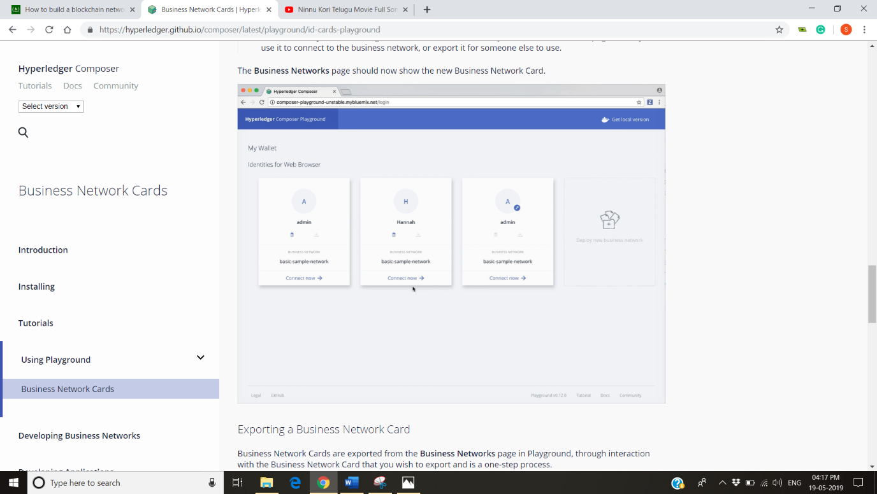

**Exporting a Business Network Card**

Business Network Cards are exported from the Business network page in Playground, through interaction with the Business Network Card that you wish to export and is a one step process. On the Business Network page, click the Export icon on the Business Network Card you wish to export. The Business Network Card should download as a .card file.

**Gaining Access to a Business Network**

**Importing a Business Network Card**

Importing aBusiness Network Card allows you to connect to a deployed Business Network.

1. In the upper right of the Business Networks page, click Import Business Network Card.
2. Drag and drop, or browser, to select a Business Network Card (.card) file to import. Click Import.

The Business Network Card should now be visible in your Business Networks page, you can now connect to the deployed Business Network.

**Connecting using Credentials**

From the Business Networks page there are two ways a Business Network Card can be created. By using the certificates that requires a certificate and private key, given by the admin of Business Network that a name if the Business Network Card where the business network name with valid credentials and the Connection Profile details for the runtime on which the target business network is deployed.

To create a Business Network Card from the Business Network page using certificates

1. After receiving a certificate and private key, click the Connect using credentials button in the upper right of the Business Network page.
2. If you have previously connected to the deployed runtime, select it from the display list, click Next and proceed to step 4 . Otherwise select the radio option to connect to a new Blockchain and click Next.
3. Specify the Connection Profile details that were provided to you and save it.
4. Enter the certificate, private key, Business Network Card name and Business Network name and click Create.

The Business Network Card should now be displayed in the Business Networks page.

**Manually Creating a Business Network Card**

Business Network Cards are archive (.zip) file containing up three elements

1. Connection Profile (.json)
2. A metadata file containing the data for the identity to use to connect to the Business Network. (metadata.json)
3. An optional credentials directory containing a certificate and private key,

The metadata file should take the following format

{

"name": "PeerAdmin",

"description": "A valid Business Network Card",

"businessNetwork": "basic-sample-network",

"enrollmentId": "UserID",

"enrollmentSecret": "UserSecret",

"roles": [

]

}

The businessNetworkName, image, enrollmentSecret and roles properties are optional. The available roles are PeerAdmin and ChannelAdmin. To create the Business Network Card file, compress the Connection Profile, metadata file and optionally a credentials directory, then modify the file type to .card. the Business Network Card can now be imported using he Hyperledger Compose Playground.

**Structure of Blockchain:**

As records have been created through a person medical life that contain similar medical information have been stored in different databases making them vulnerable, ineffective, costly to maintain and difficult to access if the same person consults another doctor or hospital. MYCONTEXT cancer patient records have the single agenda of making those all record decentralized and making them available to all who are supposed to view them. The structure of Blockchain is well-ordered and back-linked list of transaction blocks created for each transaction made. In Blockchain for every transaction we made a block is been created with a hast value assigned to it. A transaction may be new data that has been stored in the Blockchain, data that has been updated or the data that has been deleted. For very new transaction a new block is created at the end to already existing block.

There is now permanent deleting of data from the blockchain it is just updating the new data. Once a data is entered into the Blockchain it if there forever. Blockchain doesn’t contain any information in it. It’s the information of the information that is been stored in a data base which is metric data. A block in Blockchain is a simple description of what kind of data is stored in which database and what kind of information does it contain in it. There is no proof of data stored in Blockchain because Blockchain is the actual proof. There will be no difference in data stored in Blockchain and data in Blockchain is same in all platforms or systems no matter we are access it. Whenever the data in a block of Blockchain is altered or changed, that change is resembled across all the systems where that data is stored and can be viewed all the users using the Blockchain. Moreover, we can trace back to the user who made those change and everyone has to access to those changes to make it decentralized. If anyone disagrees then the change has to be reassessed.

For the case of MYCONTEXT cancer patient medical whenever a patient visits a hospital or a doctor a new medical record is created a new block with a hash value assigned to it is created. If the same patient visits another doctor or hospital, then a new block is created with a new hash value at the end of existing block in a Blockchain. If a transaction of data is made between the patient and a client who can be a research organisation or a paramedical company, then a block with a hash value containing the information related to the transaction .If an update is made to the data that is already available on Blockchain then also a new block with a new hash value is created. So, it is very hard to alter the data present in Blockchain making it safe and secure. Only the persons who are authorised, in our case a doctor or a hospital inly can make any changes to the data.

**How Blockchain will solve the problem?**

Clinical Records are generated throughout a person’s life relating to their points of care, interventions and treatments as and when they need them. These records hold valuable details of a private and confidential nature. The sharing of this information can be difficult to monitor and in clinical scenarios could lead to a compromise of data security.

The ability to “own” and access these details would be a paradigm shift in the management of Clinical detail. The added capability to share and moderate access would significantly add to the value of this type of information. The use of Blockchain encryption in the securing and sharing of these records is a relatively new approach to how data is stored, activated and permissible structures around its’ use. Blockchain opens up a whole new economy for the advanced use of these details for research and development, as well as advancing the immediacy of its availability.

Use of Blockchain and “zero knowledge” data access, as well as distributed ledgers will allow for the building of an advanced identity management platform where Patient’s (Data Owners), Institutions, Clinical and Support staff will be registered. These users can “share” access to records and responsibility for the input details. This will allow the warranty and trust for access and input trails as well as provenance of the details to be validated forward.

MyCONTEXT Cancer Record intends to leverage the power of Decentralised Ledger Technology (DLT) to offer increased availability, governance and efficient access to a Patient’s record across the spectrum of Cancer care interventions. This will create new efficiencies for patients, Cancer Services and others in the delivery of health interventions by reducing the time and effort taken to achieve access to timely, and complete patient records and collaborating practitioners

**Assets**

In our case of MYCONTEXT cancer patient medical records assets are the data or the records that have been stored in a Ledger. But we are not going to show the detail information of our assets, but we will be displaying the description of data.

**Participants**

Participants are those everyone who got a relation to the data that has been stored in Blockchain. For cancer patient medical records participants are the patient for whom the records have been created, the hospital or a doctor who creates the data of patient and the clients to who the data have been traded by the patient.

**Events**

Every action that has been dine in the Blockchain is an event. For example, if a new block is created then it is an event, if an update is made to the data that is already present in the Blockchain then it is an event, if we delete the data present in the Blockchain then it is an even and if a transaction is made between the patient and client then it is also recorded as event. For every transaction made between the patient and number of clients a new event take place.

**Permissions**

Certain permissions are assigned to particular person using the Blockchain. For cancer patient medical records patient can view all the data regarding his medical history but cannot make any changes in the data, doctor can view all the data of the patient and can make any changes to the data of the patient if it is necessary and clients can view only the part of the data they are supposed to see. They neither can see the full data nor make any changes. This provided the transparency and authenticity that the Ledgers need and stop constant tempering with the data. If permissions are not implemented, then patient can make any changes he thinks so without any prior medical knowledge making the data loose his authenticity. So, these permissions provide the authenticity required for the for the Legers in Blockchain.

**Models**

**Classes**

**Transactions and relationship between transaction and entity**

**Model- Subclasses**

**Transaction Working**

Reference:

1. <https://hyperledger.github.io/composer/latest/installing/installing-index>
2. <https://medium.freecodecamp.org/how-to-build-a-blockchain-network-using-hyperledger-fabric-and-composer-e06644ff801d>.